Diesel Miss-Match Shoulder Bag
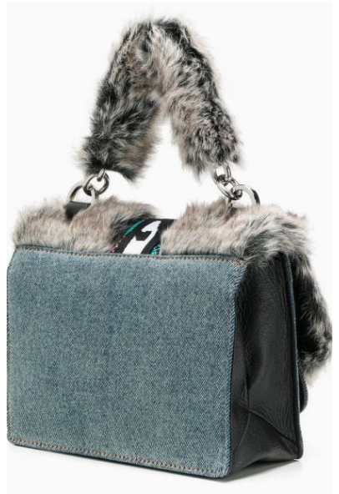
$305

Miss-Match shoulder bag in blue cotton denim and Diesel black sheep skin with a loop on the top, magnetic flap closure, logo on the front and interior pockets.

